**Office Supplies Exercise**

Open up OfficeSupplies.csv file in Tableau: File -> Open -> Browse and Select File.

In the Connections Page you will see the a preview of the Office Supplies file listed:

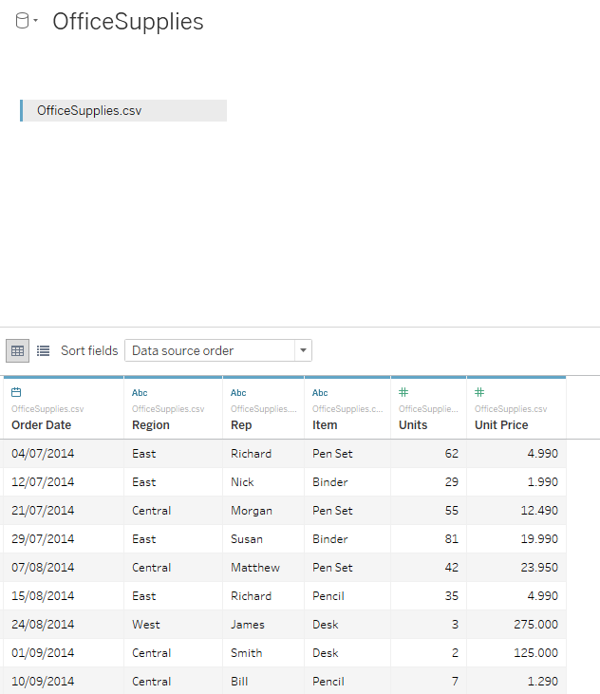

Note icons indicating data type at the top of each column.

Click on “Sheet1” (bottom left of window) to go to the Tableau Dashboard.

The Tableau Desktop is displayed:

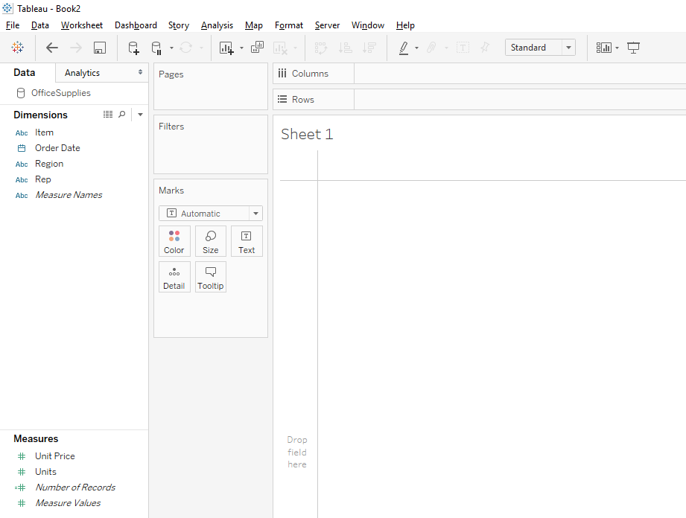

Note that variables have been separated into “Dimensions” and “Measures”.

Create a Bar Chart

In the Tableau Desktop screen drag “Rep” from the Dimensions panel and drop onto “Columns”, drag “Units” from “Measures” panel and drop on “Rows”. You should see the following:

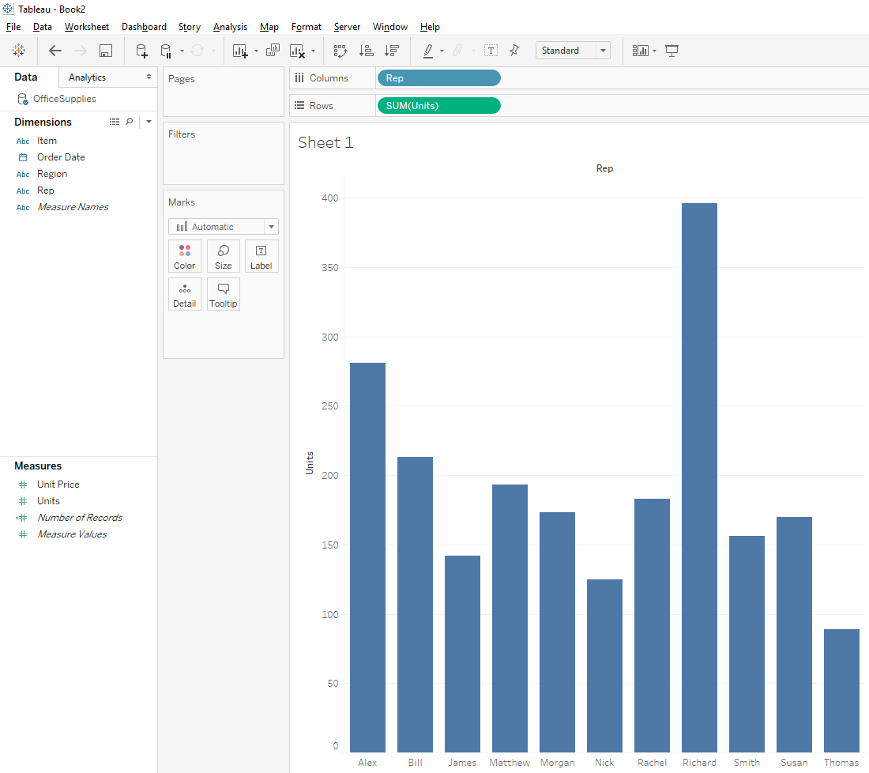

**Break down by region:**

Drag “Regions” from the “Dimensions” panel and drop into “Columns” **BEFORE** “Rep”. This will separate the bars into three regions as follows:

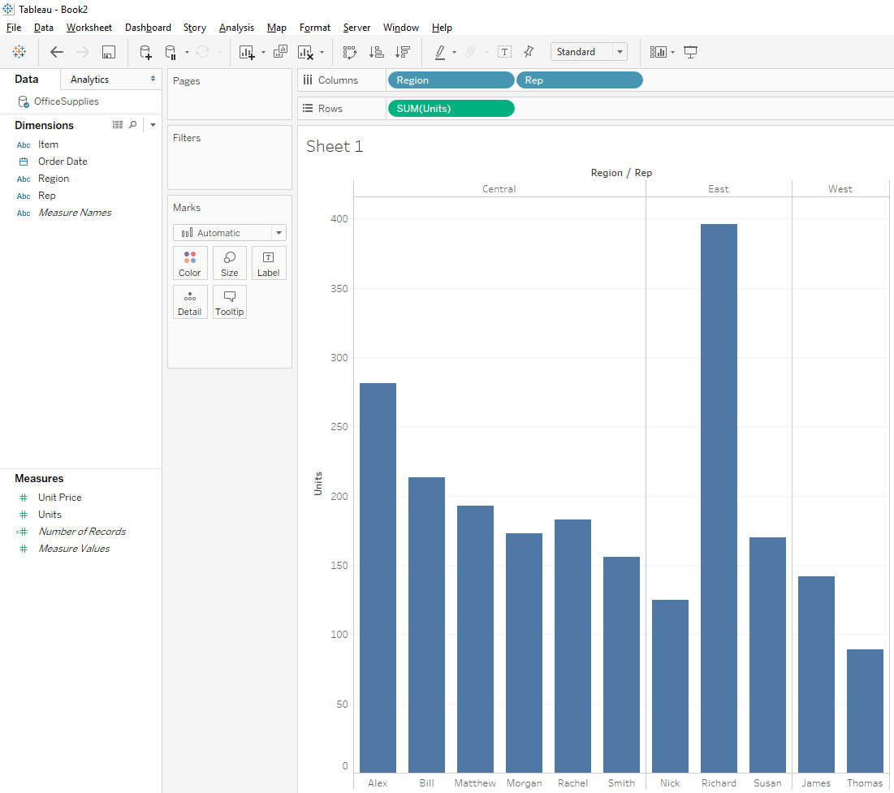

Sort each column by size within each region by clicking on “Units” label on Y axis (circled below):

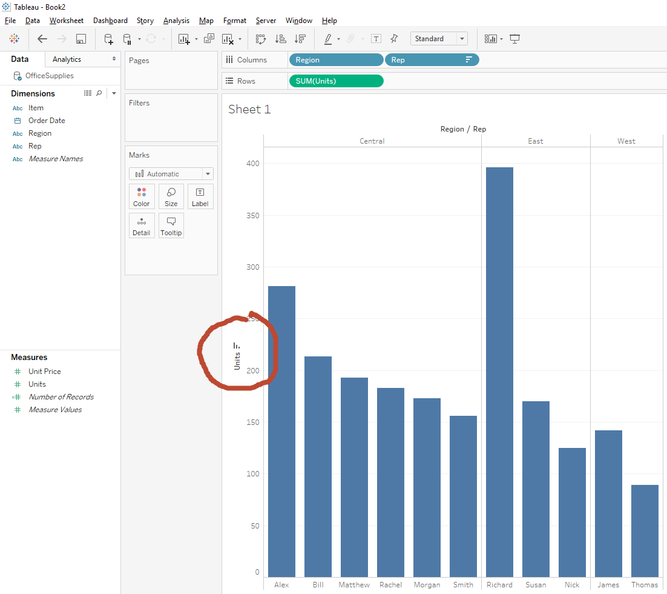

“Units” is number of items sold. Based on these figures the best salesperson is Richard. However, the best sales person is identified by dollar amount – no variable for this. Therefore we have to calculate it.

Dollar value = Units Sold x Units

To recheck data file, select options as follows:

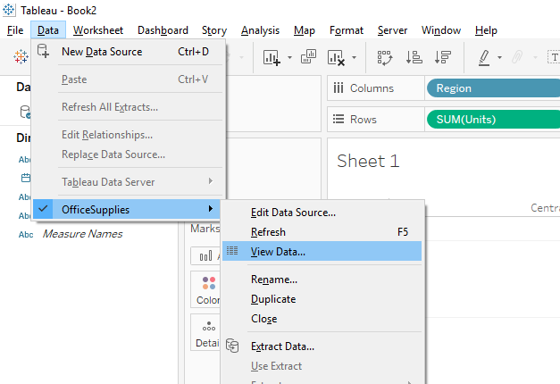

You will then see the Office Supplies data as follows:

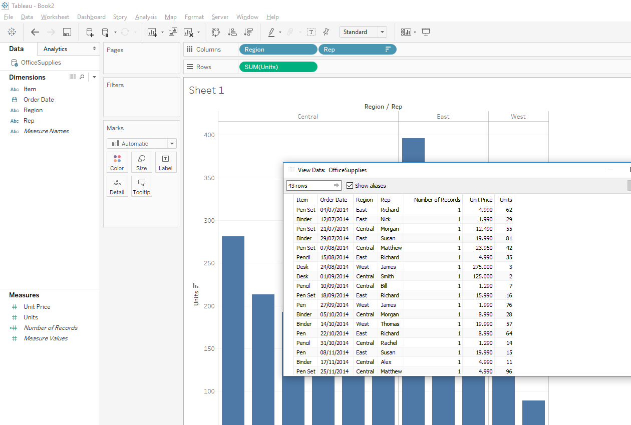

You can see that each sales person’s figures are based on number.

To set up a new calculation, right click in the blank space in the “Measures” panel and select “Create Calculated Field”:

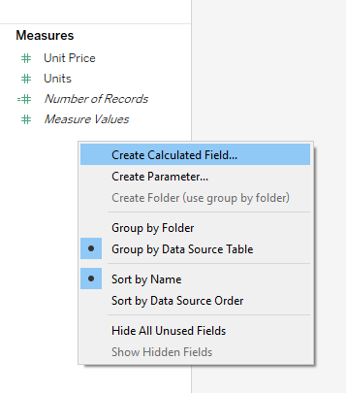

You will then be presented with a small window as follows:

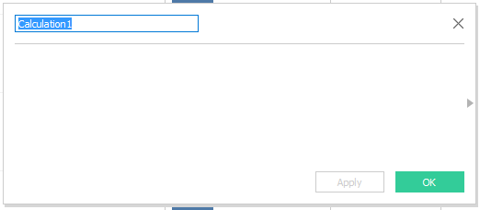

Rename “Calculation1” with a meaningful name like “TotalSales”, then click the blank area in the window, ensuring that your cursor is flashing in the window. Here you will enter the formula to multiply “Units” by “Unit Price”. To do this, simply type in the first letter (“U”) of the variable name:

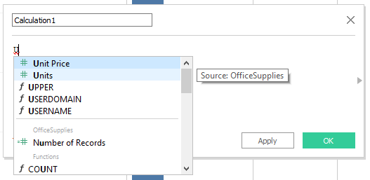

Tableau will automatically start to list all variables and items beginning with (in this case) the lketter “U”. You can continue to type or selct “Units” from the list. Then add the multiplication symbol (astersisk) and type in the “Unit Price” for the second variable as before. You should then see the formula as follows:

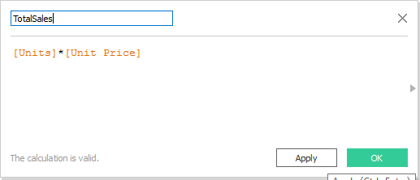

And click “Apply” or “OK”.

You should then see the “TotalSales” variable now listed in the “Measures” panel:

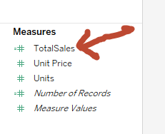

Now drag “TotalSales and drop into the “Rows” right on top of the “SUM(Units)” variable – this should replace the previous variable. Tableau will update the chart as follows:

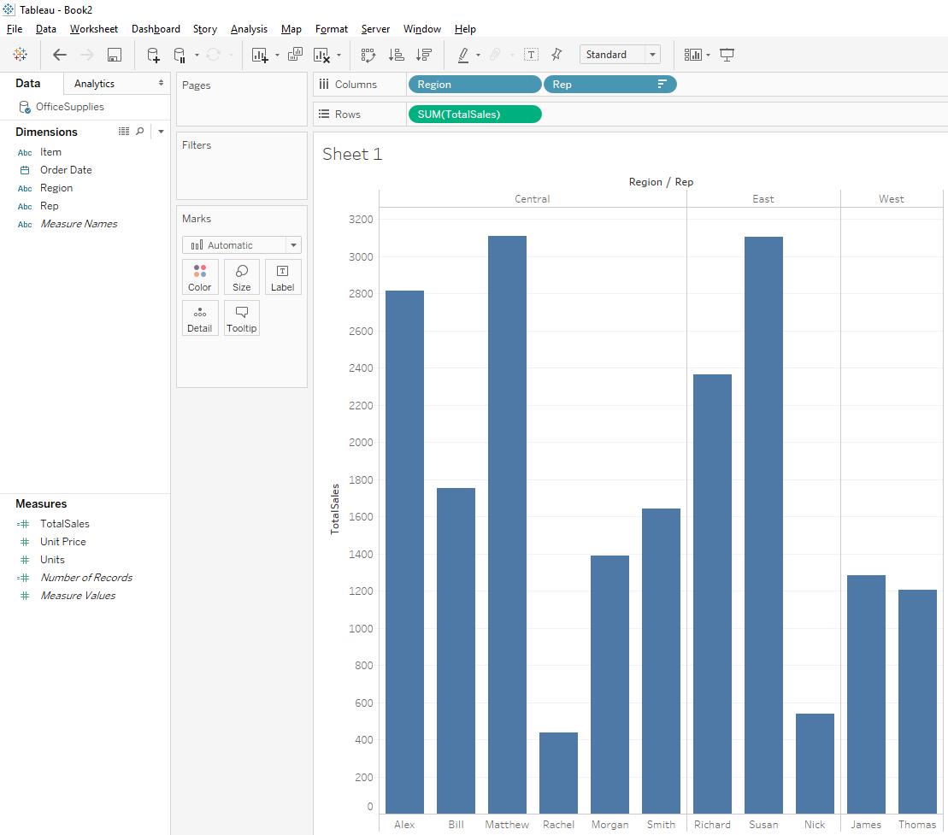

Order again by clicking on “TotalSales” label of Y-Axis – the chart updates as follows:

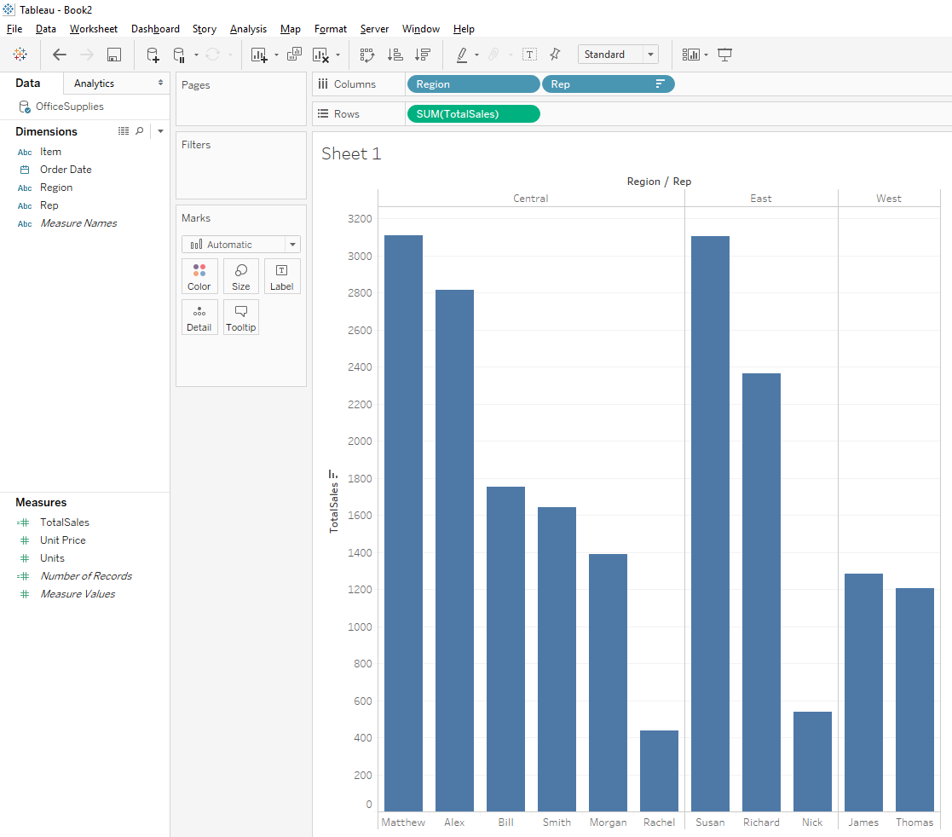

This presents a different picture of who the best salesperson is (Matthew).

Add colours to the Bar Chart

Use the “Color” button on the “Marks” panel to make changes to the colours of the chart:

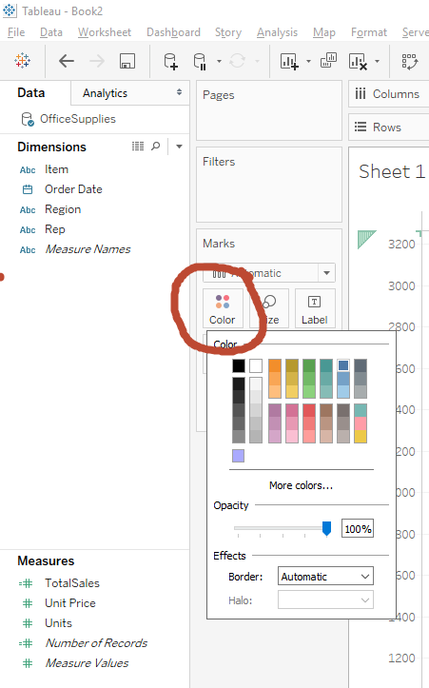

Select any colour to change the colour of the bars – experiment with this until you are happy with your colour:

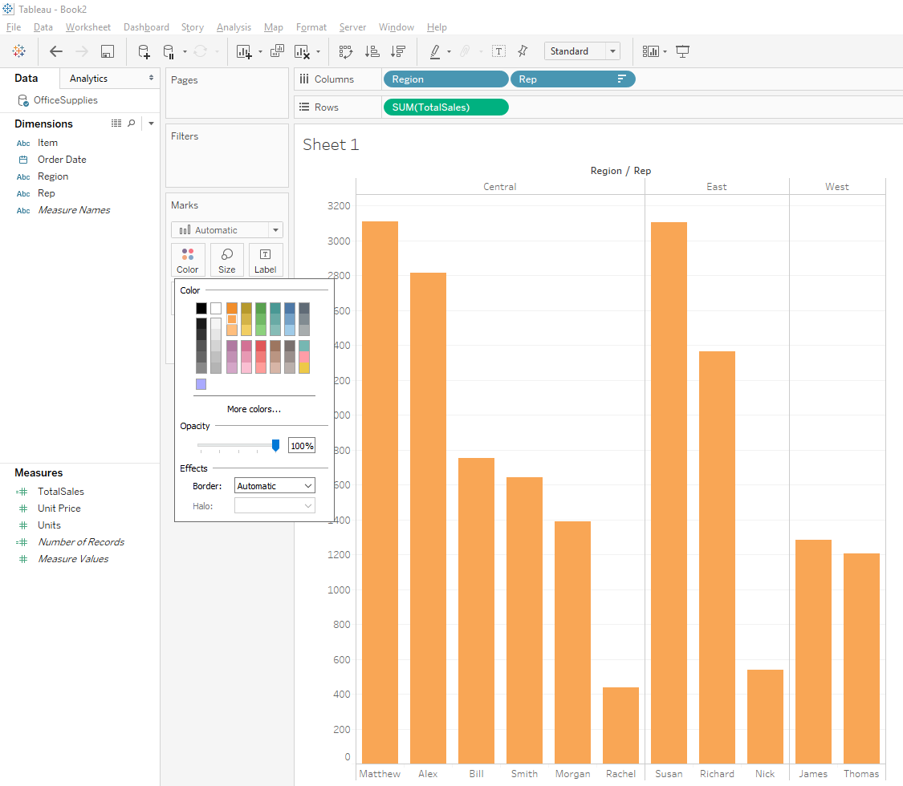

But we want colours to be different for each bar. To do this, drag “Rep” from the “Dimensions” panel and drop it onto the “Color” button:

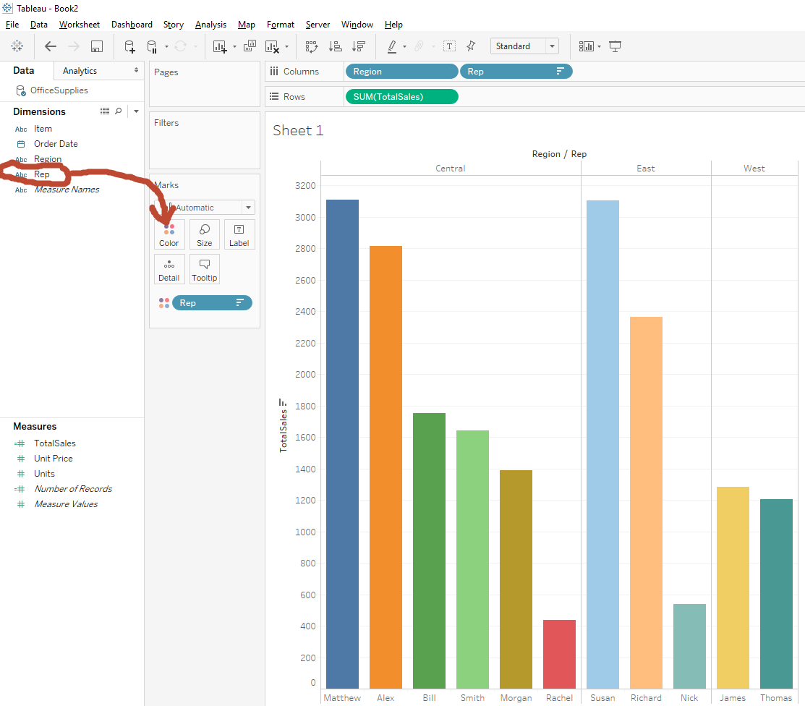

Each Rep now has a new colour. You can change each colour or choose a “Color Palette”:

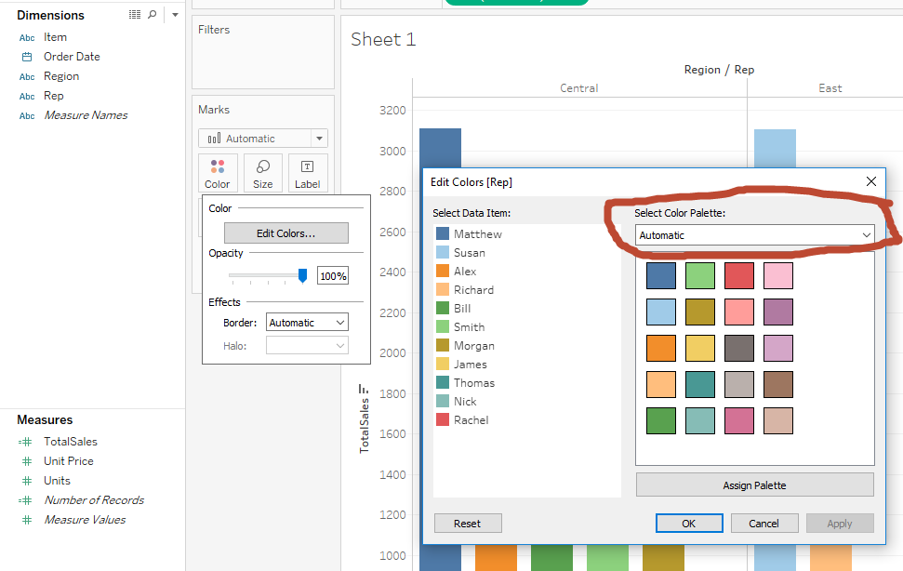

Experiment with the colours until you are happy with your colour scheme.

Use Continuous colours as follows:

Click and hold the “SUM(TotalSales)” from the Rows and drop it onto the “Color” button:

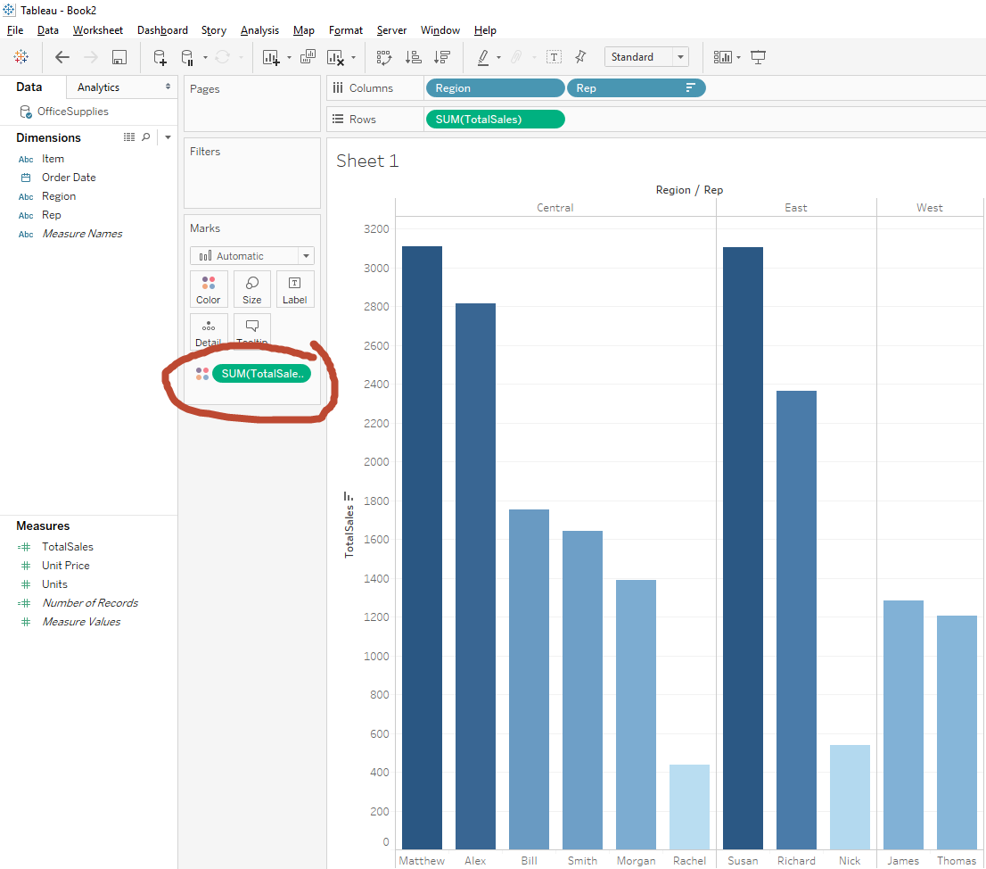

Note that “SUM(TotalSales)” has replaced “Rep” in the “Marks” panel (circled above) – each region is now represented with a colour gradient.

To give each region its own colour (in the chart above, the gradient does not add much values as the bar size already indicates differences in value), click and hold “Region” on the Columns and drag/drop it onto the “Color” button in the “Marks” panel. Each region should get its own colour as follows:

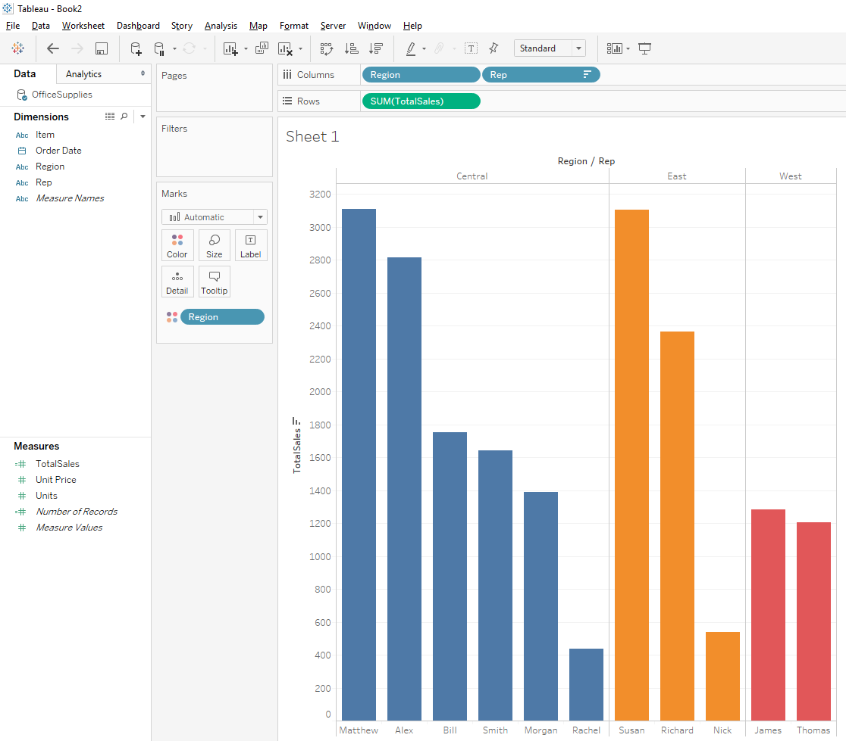

Again – you can use the “Color” button to change the colours on your chart to whatever your personal preference is.

Add Labels to your Chart

To add total sales amounts to each bar, click/hold “SUM(TotalSales)” on the Rows and drag/drop onto the “Labels” button in the “marks” panel – this will add the totals for each bar to the chart as follows:

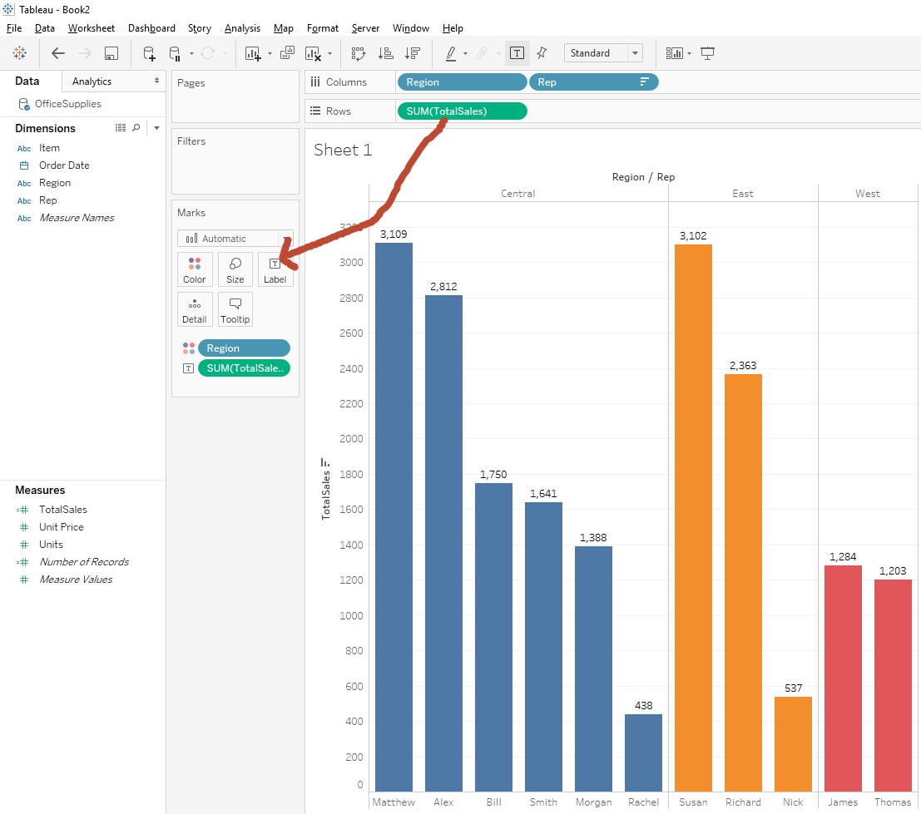

Format Chart. To change size of labels click on the “Label” button and select “Font” – choose the font and colour/size/format that you prefer:

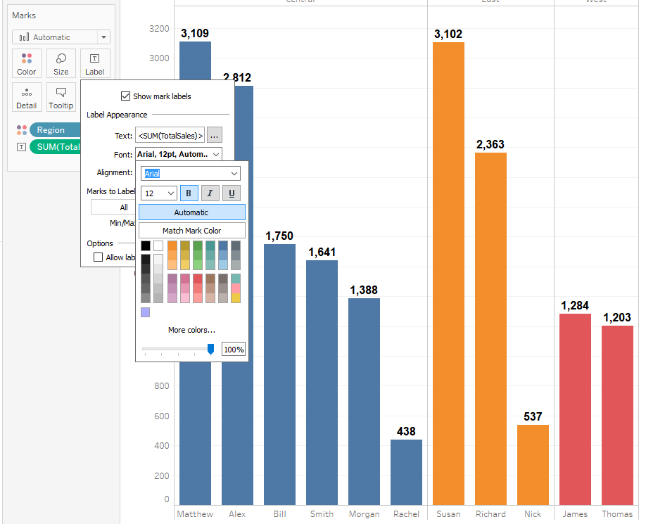

To change the type of lable, first right click on the “SUM(TotalSales)” variable in the Marks panel, this will generate a pop-up menu as follows:

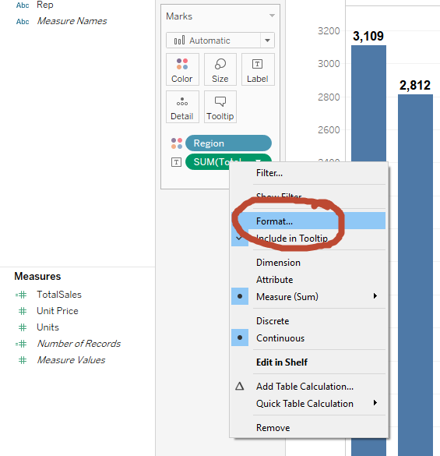

Select “Format” and the left panel of the Tableau desktop changes as follows:

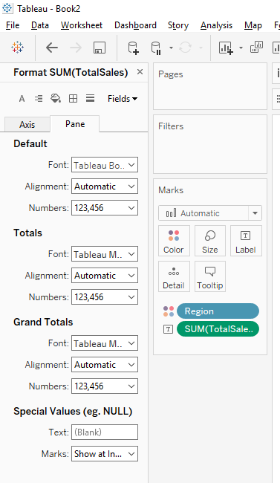

To change the data labels from “Number” (default) to “Currency”, select “Number” in the “Default” section of the left panel and choose “Currency (Standard)” to add the euro sign to the chart:

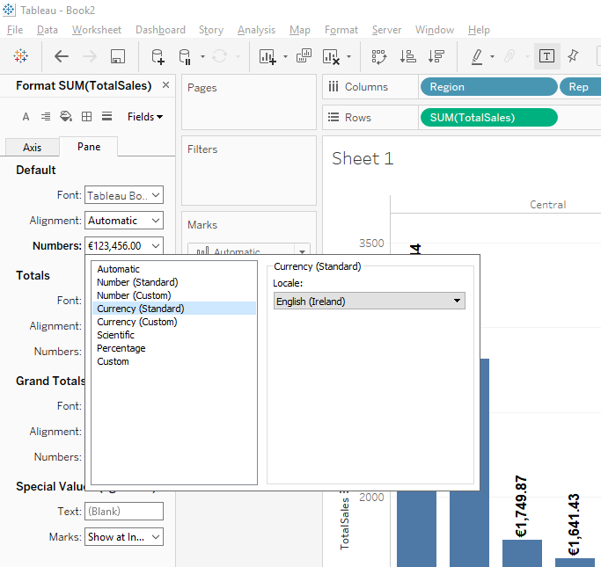

Experiment with these formatting options until you achieve the style of chart that you are happy with. Your final chart should look something like this:

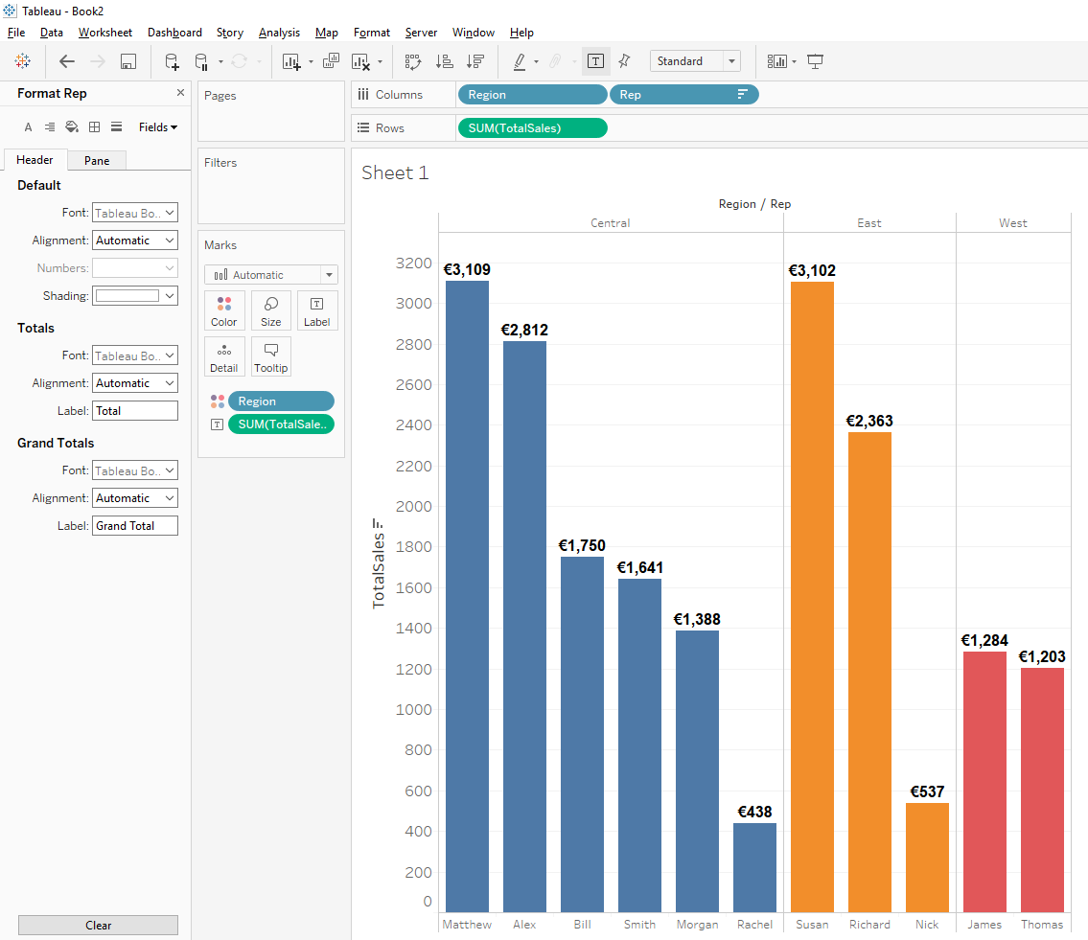

To export your chart to other documents such as a Word or PowerPoint document, select the “Worksheet” menu, then “Export”, and “Image”:

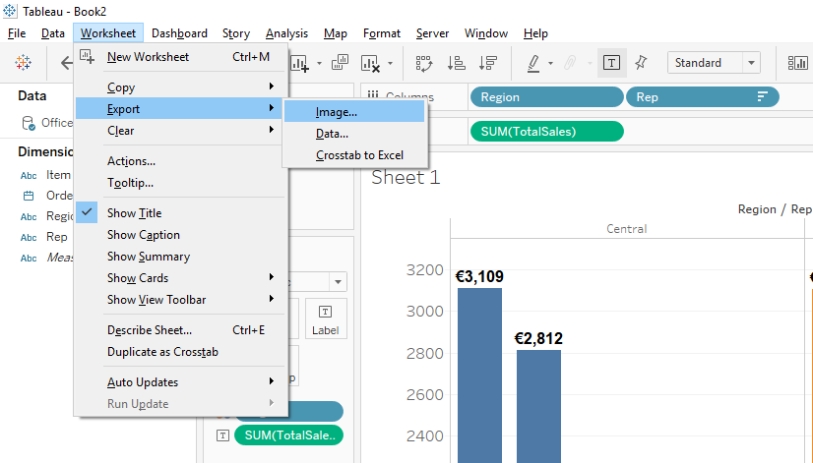

You will then see a window that allows you to set/change options for export:

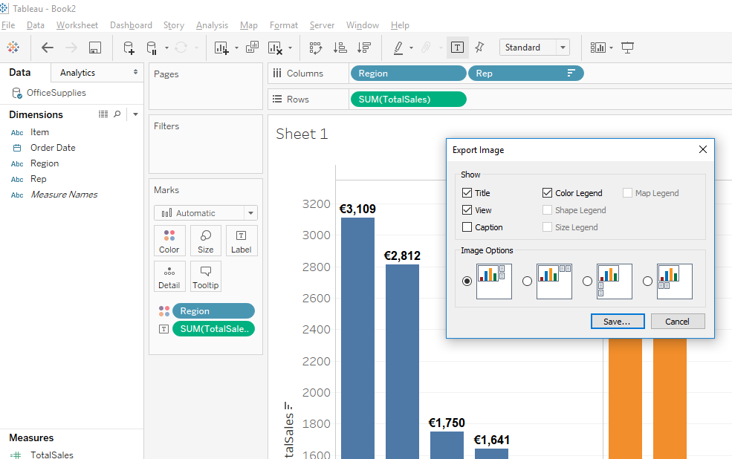

For example, you can change the position of the legend or remove title. This will save you chart as an image - .PNG is the default image format, but you can select other formats such as .BMP or .JPEG while saving. This file can now be inserted into other documents.